A

Project report on

SMART GROCERY SHOPPING ASSISTANT WITH BASKET ANALYSIS

A Dissertation Submitted in partial fulfilment of the

Requirements for the award of

BACHELOR OF TECHNOLOGY

IN

CSE ( ARTIFICIAL INTELLIGENCE AND DATA SCIENCE )

Submitted by

R. NAGAVENI (Team Leader)

P. DHANA SRI

M. JYOTHIKA

Under the esteemed guidance of

**Mr. AMJOY EXSON**

**( Coapps Data science trainer)**



DEPARTMENT OF COMPUTER SCIENCE ENGINEERING

ST.MARY’S GROUP OF INSTITUTIONS, GUNTUR

(Afflicated by JNTUK, Kakinada)

April 2024



DEPARTMENT OF COMPUTER SCIENCE ENGINEERING

**BONAFIDE CERTIFICATE**

This is to certify that this Project titled “ SMART GROCERY SHOPPING ASSISTANT WITH BASKET ANALYSIS” is being submitted by team during the Internship period April 2024, in partial fulfilment of the requirement for the award of certificate for three months internship training in Data Science trained by Coapps company in Chennai .It is a record and bonafide work carried out by him under our guidance and Supervision. The results presented in this project report have been verified and are found to be satisfactory.

**TEAM : R. NAGAVENI (Team Leader)**

**P. DHANA SRI**

**M. JYOTHIKA**

**________________________________**

**Mr. AMJOY EXSON**

**(Coapps data science trainer)**

**ACKNOWLEDGEMENT**

I express my sincere thanks to COAPPS company .

I wish to record my thanks to my guide Mr.AMJOY EXSON for his constant Support enthusiasm and motivation

I wish to express thanks to all the Trainers in the department of Data science for their support throughout this project, I also thank my Friends for their moral support and suggestion for this work.

Finally, I thank one and all those who have rendered help directly or indirectly at various stages of the project.

**TEAM : R. NAGAVENI (Team Leader)**

**P. DHANA SRI**

**M. JYOTHIKA**

DECLARATION

I hereby declare that the project work “SMART GROCERY SHOPPING ASSISTANT WITH BASKET ANALYSIS“ submitted to the State Tamilnadu is a record of an original work done by me under the guidance of Mr.AMJOY EXSON trainer in coapps data science . This project work is submitted in the partial fulfilment of the required for the award of the Internship of Data science in COAPPS

Whenever I have used materials (theoretical analysis, existed system data, figures and text) from other sources, I have given due credit to them by citing them into text of the report and giving their details in the references.

Date : 21-04-2024

Place : GUNTUR

**ABSTRACT**

A Technique that check for dependency for one Data item to another is Association Rule which is an old Data mining approach. Which is used to identify the next product that might interest a customer. The Apriori Algorithm is applied in this for mining frequent products sets and relevant Association rule. With this algorithm we can use this for up-sell and also in cross-sell to show the Association rule with the help of the algorithm. These methods are widely used in global companies, so for the good understanding the companies used the methods to remain up to date that what customers demands with which products. The results helps the big retailers to identify a trend for customers buying patterns, which is very helpful information for the retailers to plan their big business operations. A grocery list is frequently used to make sure that only essential items are bought and nothing else is forgotten. Due to the extensive list of items, they must buy each month, people frequently forget what they need to buy when they get to the supermarket. Even with a list, there are still things that get left out. Therefore, an application call My Grocery is proposed that offers suggestions for items users frequently buy together and aids users in creating grocery lists. This might help them make a personalised grocery list with items that are suggested based on their past purchases. The aim is to help them keep track of what they have bought as well as to help them create personalised grocery lists. Market basket analysis is used to find associations between items in My Grocery using past purchased history. The result shown the significance recommendation by My Grocery where the Market Basket Analysis, which is carried out using the Apriori Algorithm, displayed the recommended item following the calculation of lift value.

**INTRODUCTION**

**MARKET BASKET ANALYSIS :**

In today’s World the Globalization has a huge impact on business environment. And the business place become widely available, which affecting the customers demands in different way. These business marketspace also opens a lot of business opportunities for lot of business owners , shop retailers to do better business. For the betterment the shop and complex owners try to modify the arrangement of the products for the customers betterment, after figure out that what people want on what occasions. And to succeed this is the best challenging strategies to deal with, business means to compete with others and find a strategic way. And this management gives benefit to both customers and the business owners.

Market Basket Analysis is known for association rule which is a data mining approach, means the knowledge of the relation between the items or the products in a data transaction is the best way for the betterment of business. Now a days it is the best technique used by the inventory staff to know the co relation between the frequently purchased items. This technique is used mainly for mostly daily need items like for the grocery or for dairy products. With the advancement in business the market basket analysis has widely used for many business to help them in better decision making.

Market Basket Analysis is good to help businesses in making for better decision, mostly in marketing level. A survey shows that this technique is widely implemented in most of the big enterprise companies. The purpose of market basket analysis implementation is get a better understanding of customer preferences based on customer daily transactions.

Widespread programs of Market Basket evaluation in retail are:

Contrasting income, geared toward customers to promote on the way to spend extra money on their onetime shopping baskets call the search engines like google on the website as clients who buy this additionally buy this.

Product placement or catalog composition, tell placement of content material merchandise on their media websites, or a product in its catalog

Shop constructing, placed merchandise that show up collectively next to every other, to enhance the patron buying revel in 4. evaluation of the Loss leader, the loss chief is fee approach anyplace the product is sold at complete fee underneath its marketplace fee to inspire exceptional income for added worthwhile income or services. Market Basket Analysis :

Data Mining project may be divided into two classes, first:clustering and association pattern and second : type and regression. If we are saying we've item X and item Y.

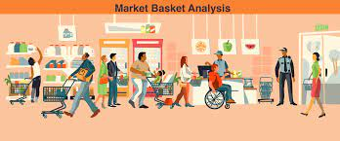

**An associated rule**

X→Y indicate that every customer that purchases X will purchase Y too

There are three types of mining in association rule mining types as shown in the figure 1:

• Frequent Itemset mining used to find a frequent object which appears inside the entire transaction.

• While application Itemset Mining focuses on finding the set above a software threshold set via the consumer.

• The utility threshold can be any parameter like value, time and so on uncommon Itemset Mining is opposite to frequent Itemset Mining, as it attempts to find a uncommon set that exists inside the dataset. introduced collection market b asket analysis , in which as opposed to locating the cooccurrence itemset, the author was focusing on analysing the shopping collection from large set of dataset.

People always make a grocery list before heading to the supermarket to ensure that they don't forget anything important. The reason for this is that when individuals go grocery shopping, they normally buy a big number of goods. As a result, some people may find it challenging to recall things without writing a list, which can increase the likelihood that they will forget anything on the list. Forgetful is common occurrences in people lives (Fernandes et al., 2016), and this includes forget items during grocery shopping. This circumstance is more unpleasant when people forget a moment before entering the grocery store. This issue may waste people's time and effort due to the forgetting concerns. Even when a shopping list is created, certain products are often forgotten. This is especially true for items that are purchased infrequently but have a long lifespan. Creating a shopping list in a rush can also add to this problem (Nath, 2021).

The problem of forgetting and overlooking can be reduced by creating an application that can recommend items based on a user's past purchases. This means that the next items they intend to purchase will be suggested based on their previous purchases and the frequency with which they make those purchases. The algorithm will suggest and recommend the next items

purchased based on the purchasing trends that have been logged. In addition, relevant products with the same purchase date will be suggested to the consumer, allowing them to swiftly add them to their shopping cart. Additionally, they can compare the prices to the current prices of the same items in the store. on each product's calorie count. Following that, this application can let users become friends. This application uses ionic method as its integrated technology. Ionic is an open-source framework for creating online applications or hybrid mobile applications. Given that it is a hybrid approach, any platform can be used. Auckland International Conference on Social Sciences,

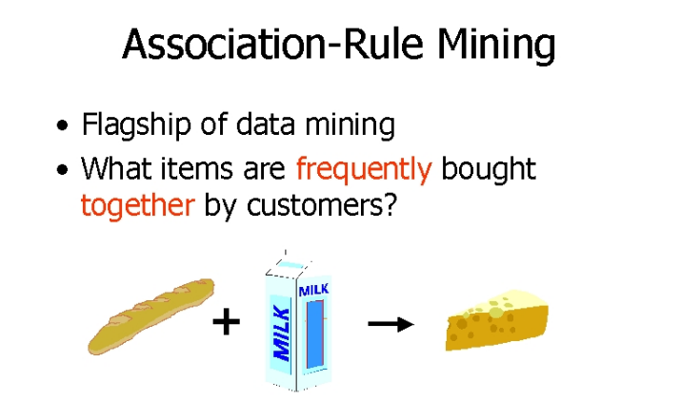

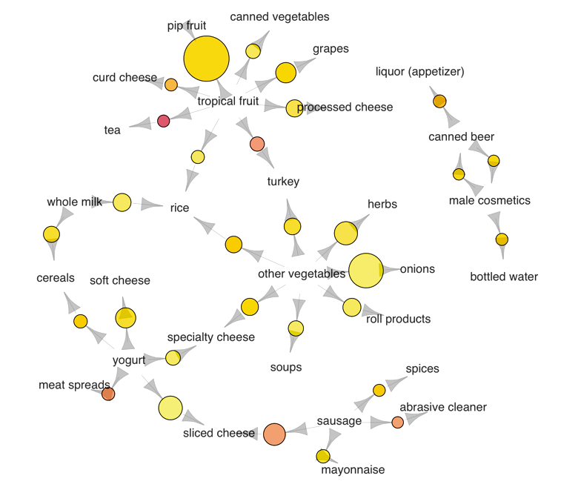

**Software tools in Market Basket Analysis :**

Market Basket Analysis (MBA) involves various software tools for data preprocessing, analysis, modeling, and visualization. Here are some of the main software tools commonly used in MBA:

1. **Python**: Python is a popular programming language widely used for data analysis and machine learning tasks, including MBA. Key libraries for MBA in Python include:
   * Pandas: For data manipulation and analysis.
   * NumPy: For numerical computing and array operations.
   * SciPy: For scientific computing and statistical functions.
   * Scikit-learn: For machine learning algorithms, including association rule mining.
   * MLxtend: A library containing implementations of MBA algorithms like Apriori and FP-growth.
   * Matplotlib and Seaborn: For data visualization.
   * These are some of the main software tools used in Market Basket Analysis, each offering different capabilities and advantages depending on the specific requirements and preferences of the user.

**Hardware tools in Market Basket Analysis :**

Market Basket Analysis (MBA) primarily relies on software tools and libraries for data processing, analysis, and visualization, rather than specific hardware tools. However, the performance of MBA tasks, especially on large datasets, can benefit from hardware configurations that provide computational power and memory resources. Here are some considerations regarding hardware tools for MBA:

• **CPU (Central Processing Unit)**: The CPU is essential for executing computations and algorithms involved in MBA tasks. Higher core counts and clock speeds can lead to faster processing times, especially for algorithms that are CPU-bound.

• **RAM (Random Access Memory)**: RAM is crucial for storing data and intermediate results during MBA operations. Larger RAM capacities allow for the processing of larger datasets without encountering memory limitations.

• **Storage**: While not directly involved in computation, fast and reliable storage solutions, such as SSDs (Solid State Drives) or NVMe SSDs, can improve overall system performance by reducing data access times and improving data transfer rates, especially when dealing with large transactional datasets.

• **GPU (Graphics Processing Unit)**: While not traditionally used in MBA, GPUs can accelerate certain computations, such as those involving parallel processing or deep learning-based approaches. However, most MBA algorithms are CPU-bound rather than GPU-bound.

• **Cloud Computing**: Cloud computing platforms offer scalable computing resources on-demand, allowing users to perform MBA tasks without the need to invest in on-premises hardware. Providers like Amazon Web Services (AWS), Google Cloud Platform (GCP), and Microsoft Azure offer a variety of virtual machine configurations suitable for MBA workloads.

**Methodology**

**System Design**

1. **Flow Diagram for My Grocery Recommendation**

Figure 1 shows the flow diagram on the My Grocery using A Prioriri Algorithm for suggesting grocery items. The Apriori algorithm will be used once the user has chosen or added any products to the shopping list, and it will identify the item that is typically chosen alongside the selected item based on past purchases. The list will not have any recommendations if no items

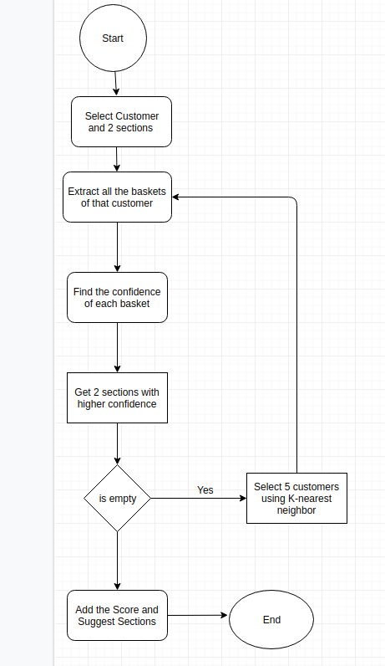

1. **Apriori Algorithm:**

Figure 2 depicts the Apriori algorithm steps. When a user adds an item to their shopping list, the system reads the information for each item and calculates its support before recommending it to the user. The estimated support will be entered as a frequent item-set if it is higher than the minimal support or equal to it. The confidence will then bedetermined, and if it

The Apriori algorithm is a classic algorithm used in data mining for frequent item set mining and association rule learning over transactional databases. It is designed to discover interesting relationships hidden in large datasets. The algorithm works by generating candidate item sets of increasing lengths and then scanning the database to determine the support (frequency) of each item set. Item sets that meet minimum support thresholds are considered frequent, and from these frequent item sets, association rules can be derived.

Here's a simplified overview of how the Apriori algorithm works:

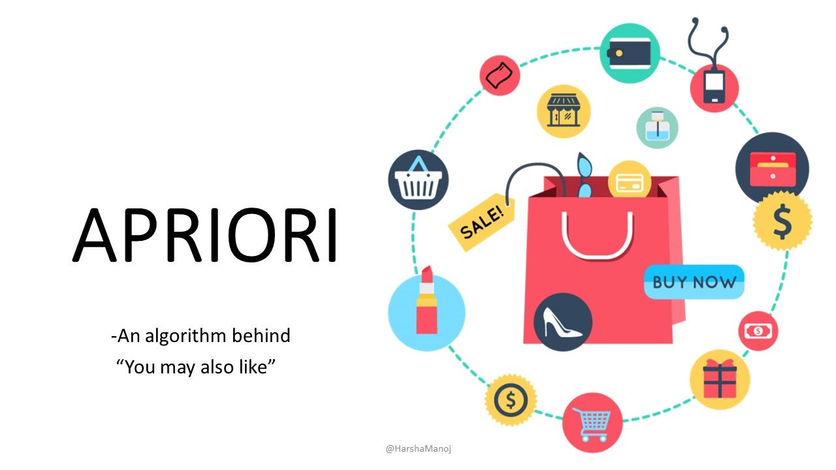

1. **\*\*Generate Candidate Item Sets**:** Begin by identifying all single items in the dataset. Then, combine these items to form candidate item sets of length 2.

**2. **Scan the Database**:** Count the occurrences of each candidate item set in the database. If the count meets a predefined minimum support threshold, it is considered a frequent item set.

**3. **Generate New Candidate Item Sets**:** Using the frequent item sets discovered in the previous step, generate new candidate item sets of length k+1.

**4. **Repeat**:** Continue the process of scanning the database and generating candidate item sets until no more frequent item sets can be found.

**5. **Derive Association Rules**:** Once all frequent item sets are discovered, association rules can be derived from them. These rules express relationships between the presence of certain items in transactions.

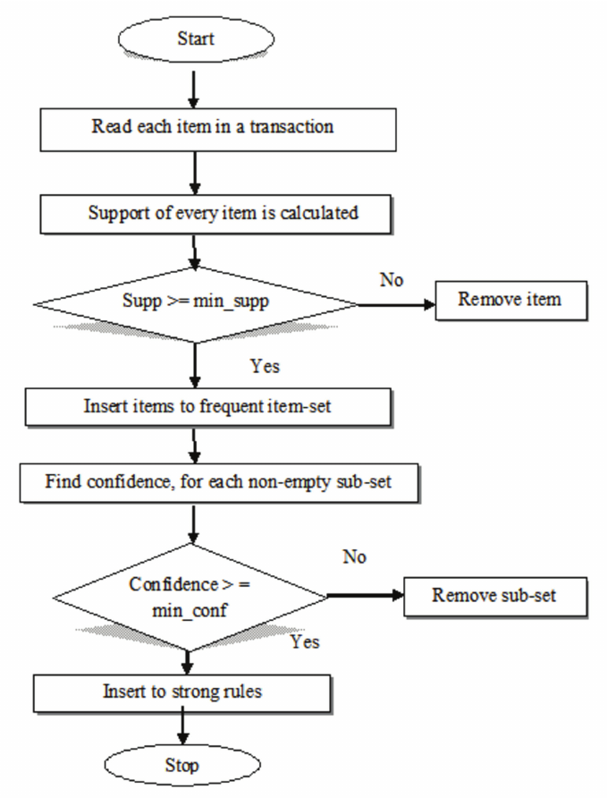

1. **Interface Design**

The application's interface was created using the Android Studio software and comprises six modules: Login, Register, Add Items, List, Shopping List, and Recommendation List. Login Module: User need to enter their email and password to login into the system. Registration Module: User need to enter their full name, email, password and phone number to register into the system. Once registration is complete, the information will be added to the database, and the user can then log in. Add Item Module: To add new data to the database, the user must input the date, the item's name, and the phone number. List Module: The user can search any item using the item's name in the search field, and related items with the same keyword will display. This will list all the data in the database that has been entered by the user. After that, if the user wants to add the item to their shopping list, they may do so by simply selecting it. Shopping List Module: The user will refer to their grocery list from the Shopping List interface when doing their grocery shopping. Any chosen items will be retrieved and placed in this shopping list. The objects that have been listed in this shopping list are viewable, editable, and deleteable by the user. Recommendation Module: The recommendation modules recommended things displayed is based on the most popular user's purchase of the item with the item thathas been chosen for the shopping list. The recommended items can be added to the user's shopping list. Apriori Algorithm is implemented in this module.

Designing an interface for the Apriori algorithm involves creating a user-friendly way for users to input their dataset, specify parameters such as minimum support and confidence thresholds, and view the results of the algorithm's execution. Here's a basic outline of what the interface might include:

**1. **Input Data Section**:**

- **Upload Dataset**: Allow users to upload their dataset in a compatible format (e.g., CSV, Excel).

- **Preview Data**: Provide a preview of the uploaded dataset to help users verify that the data was correctly loaded.

**2. **Algorithm Parameters**:**

- **Minimum Support Threshold**: Allow users to specify the minimum support threshold as a percentage or an absolute count. This parameter determines the minimum frequency required for an item set to be considered "frequent."

- **Minimum Confidence Threshold**: Optionally, allow users to specify a minimum confidence threshold for association rule generation.

- **Other Parameters**: Depending on the implementation, you may include additional parameters such as maximum item set size or pruning strategies.

**3. **Execution Controls**:**

- **Run Algorithm**: Provide a button or option to start the execution of the Apriori algorithm with the specified parameters.

- **Cancel/Stop**: Allow users to cancel or stop the execution if needed, especially for large datasets.

**4. **Output Section**:**

- **Frequent Item Sets**: Display the frequent item sets discovered by the algorithm, along with their support counts.

- **Association Rules**: Optionally, display association rules generated from the frequent item sets, including the antecedent, consequent, support, confidence, and any other relevant metrics.

- **Visualization**: Provide visualizations such as graphs or charts to help users understand the relationships between items and item sets.

**5. **Export and Save**:**

- **Export Results**: Allow users to export the results of the algorithm (frequent item sets, association rules) to a file for further analysis or sharing.

- **Save Parameters**: Optionally, allow users to save their parameter settings for future use.

**6. **Feedback and Help**:**

- **Documentation**: Provide documentation or tooltips to help users understand each parameter and how to interpret the results.

- **Feedback**: Include a way for users to provide feedback or report issues with the interface or algorithm.

**7. **Advanced Options**:**

- **Advanced Settings**: For experienced users, provide options for advanced settings or customizations, such as different pruning strategies or algorithm variations.

The interface should aim to be intuitive and easy to use, guiding users through the process of configuring the algorithm and interpreting the results. Visual aids and clear labeling can help users understand the various parameters and outputs of the algorithm. Additionally, error handling and informative messages can improve the user experience by providing guidance in case of incorrect inputs or unexpected issues.

**Implementation of Market Basket Analysis using Apriori Algorithm**

Market Basket Analysis is written in Python and implemented in Jupyter Notebook (anaconda 3 The Apriori algorithm and the association rule were used to determine the frequent item-set in order to implement the Market Basket Analysis. The first step is to import the related function into the system to ensure that the calculation works properly. a. Dataset: The CSV file containing the 6-month grocery list dataset is utilised for market basket analysis. The items are organised by month.

1. **Dataset:**

The CSV file containing the 6-month grocery list dataset is utilised for market basket analysis. The items are organised by month. As seen in Figure 3, each column reflects products purchased for a month.

Columns of my dataset :

Index(['order_id', 'product_id', 'add_to_cart_order', 'reordered',

'product_name', 'aisle_id', 'department_id', 'aisle', 'user_id',

'eval_set', 'order_number', 'order_dow', 'order_hour_of_day',

'days_since_prior_order', 'department'],

dtype='object')

final_df.head(10000)

|  | **order_id** | **product_id** | **add_to_cart_order** | **reordered** | **product_name** | **aisle_id** | **department_id** | **aisle** | **user_id** | **eval_set** | **order_number** | **order_dow** | **order_hour_of_day** | **days_since_prior_order** | **department** |
| --- | --- | --- | --- | --- | --- | --- | --- | --- | --- | --- | --- | --- | --- | --- | --- |
| **1374617** | 2093037 | 19368 | 1 | 1 | With Glade Tough Odor Solutions Cat Litter | 41 | 8 | cat food care | 149356 | train | 18 | 3 | 16 | 21.0 | pets |
| **1374618** | 2431740 | 54 | 3 | 0 | 24/7 Performance Cat Litter | 41 | 8 | cat food care | 96182 | train | 15 | 0 | 11 | 5.0 | pets |
| **1374619** | 2788515 | 23329 | 3 | 1 | Organix Chicken & Brown Rice Recipe | 40 | 8 | dog food care | 80423 | train | 25 | 2 | 20 | 30.0 | pets |
| **1374620** | 762699 | 17658 | 4 | 1 | 6\" Free Ranger Bully Stix | 40 | 8 | dog food care | 11371 | train | 6 | 6 | 15 | 30.0 | pets |
| **1374621** | 2597546 | 20170 | 3 | 0 | Beef Jerky | 40 | 8 | dog food care | 91946 | train | 19 | 6 | 9 | 14.0 | pets |
| **...** | ... | ... | ... | ... | ... | ... | ... | ... | ... | ... | ... | ... | ... | ... | ... |
| **1384612** | 2203844 | 44218 | 1 | 0 | Duct Tape | 6 | 2 | other | 109269 | train | 11 | 3 | 14 | 30.0 | other |
| **1384613** | 2221946 | 3994 | 1 | 0 | Max Bed Bug and Flea Killer | 6 | 2 | other | 24500 | train | 9 | 0 | 9 | 10.0 | other |
| **1384614** | 2417998 | 39511 | 2 | 0 | Baby Diaper Rash Ointment | 6 | 2 | other | 151951 | train | 12 | 0 | 12 | 20.0 | other |
| **1384615** | 2462087 | 19109 | 1 | 0 | Antifungal Clotrimazole Cream | 6 | 2 | other | 168591 | train | 5 | 1 | 20 | 30.0 | other |
| **1384616** | 2969967 | 24603 | 1 | 0 | California Blush Pink Champagne | 6 | 2 | other | 178138 | train | 8 | 2 | 9 | 11.0 | other |

|  | **order_id** | **product_id** | **add_to_cart_order** | **reordered** | **product_name** | **aisle_id** | **department_id** |  | **aisle** | **user_id** | **eval_set** | **order_number** | **order_dow** | **order_hour_of_day** | **days_since_prior_order** | **department** |
| --- | --- | --- | --- | --- | --- | --- | --- | --- | --- | --- | --- | --- | --- | --- | --- | --- |
| **0** | 1 | 49302 | 1 | 1 | Bulgarian Yogurt | 120 | 16 |  | yogurt | 112108 | train | 4 | 4 | 10 | 9.0 | dairy eggs |
| **1** | 1 | 11109 | 2 | 1 | Organic 4% Milk Fat Whole Milk Cottage Cheese | 108 | 16 |  | other creams cheeses | 112108 | train | 4 | 4 | 10 | 9.0 | dairy eggs |
| **2** | 1 | 22035 | 8 | 1 | Organic Whole String Cheese | 21 | 16 |  | packaged cheese | 112108 | train | 4 | 4 | 10 | 9.0 | dairy eggs |
| **3** | 816049 | 49302 | 7 | 1 | Bulgarian Yogurt | 120 | 16 |  | yogurt | 47901 | train | 14 | 4 | 6 | 16.0 | dairy eggs |
| **4** | 816049 | 35176 | 5 | 1 | Cream Cheese Cream Cheese Spread | 108 | 16 |  | other creams cheeses | 47901 | train | 14 | 4 | 6 | 16.0 | dairy eggs |
| **...** | ... | ... | ... | ... | ... | ... | ... |  | ... | ... | ... | ... | ... | ... | ... | ... |
| **9995** | 1783567 | 48645 | 24 | 1 | Unsweetened Coconutmilk | 91 | 16 |  | soy lactosefree | 194488 | train | 6 | 3 | 17 | 24.0 | dairy eggs |
| **9996** | 1803132 | 17758 | 22 | 1 | Strawberry Rhubarb Yoghurt | 120 | 16 |  | yogurt | 33830 | train | 5 | 5 | 14 | 30.0 | dairy eggs |
| **9997** | 1803132 | 22151 | 9 | 1 | Tart Cherry Yoghurt | 120 | 16 |  | yogurt | 33830 | train | 5 | 5 | 14 | 30.0 | dairy eggs |
| **9998** | 1803132 | 37029 | 19 | 1 | Cream Cheese Spread | 108 | 16 |  | other creams cheeses | 33830 | train | 5 | 5 | 14 | 30.0 | dairy eggs |
| **9999** | 1803132 | 6719 | 4 | 1 | Mini Babybel White Cheddar Cheese | 21 | 16 |  | packaged cheese | 33830 | train | 5 | 5 | 14 | 30.0 | dairy eggs |

|  |
| --- |
|  |

1. **EDA:**

To carry out the Market Basket Analysis, the frequency of the most popular items must be acquired in order to determine the most frequently listed items by the user.

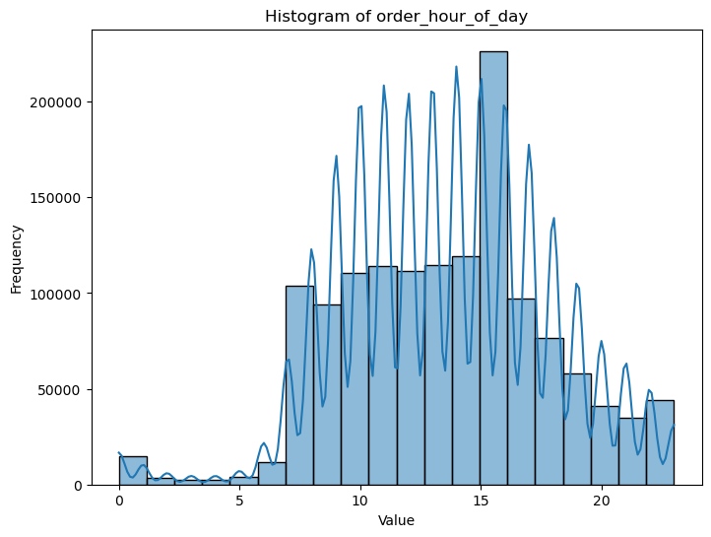 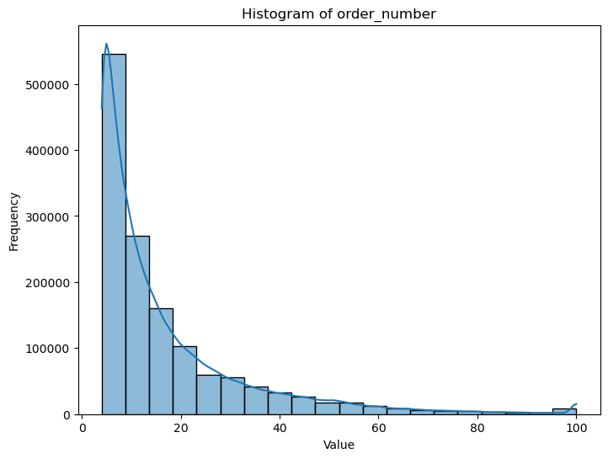

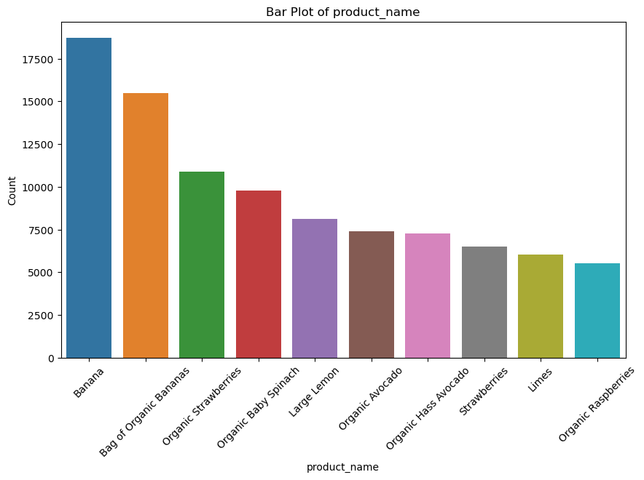

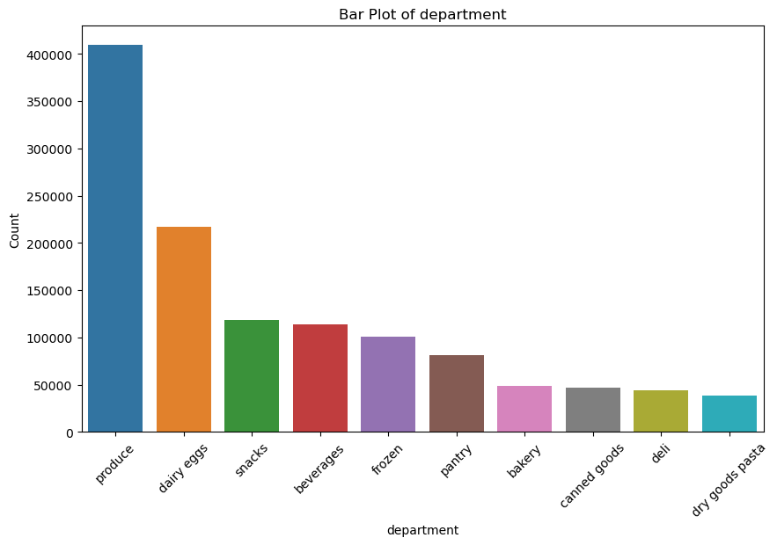

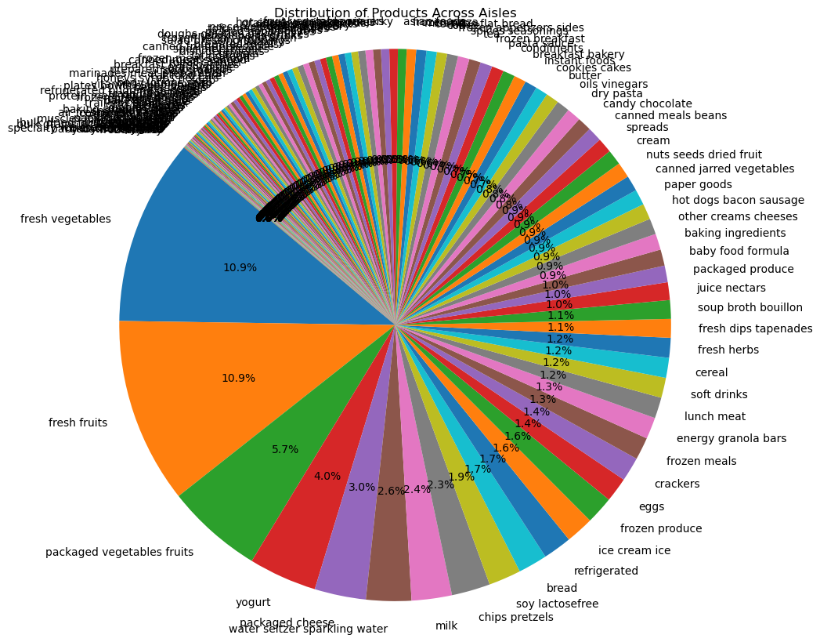

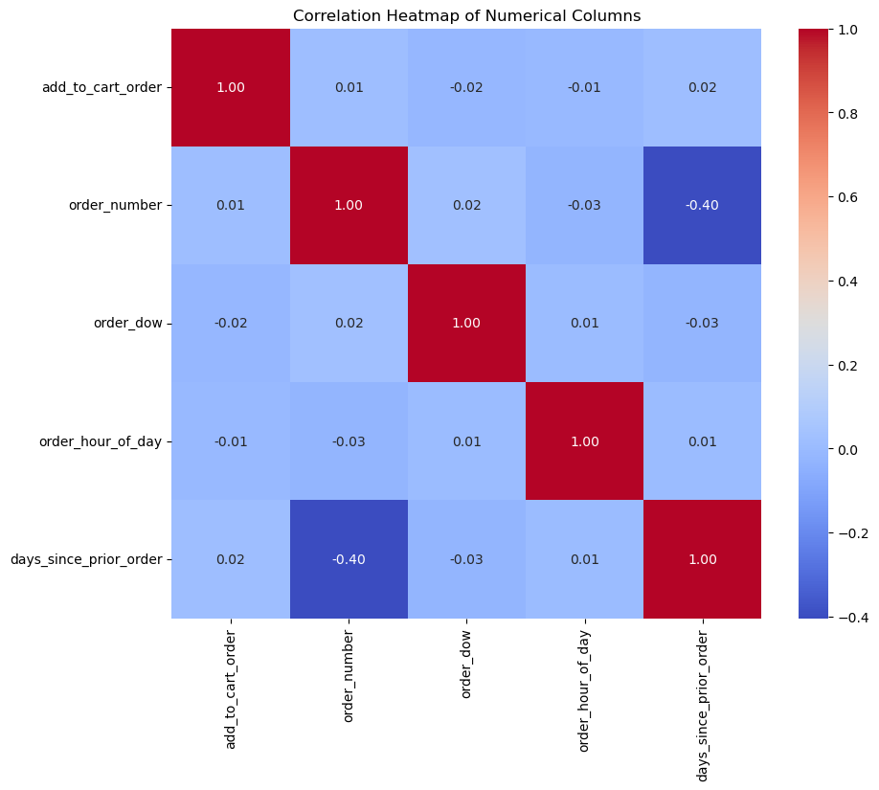

**c.Getting the list of transaction:**

After reading the dataset, the system must obtain the list of items in each transaction. As a result, there will be two loops, one for the total number of transactions and the other for the total number of columns in each transaction. As indicated in Figure 4, this list will be utilised as a training set to generate a list of association rules. The next stage is to extract the unique items, after which the items with a 'nan' value will be removed.

1. **One-hot encoding transaction data:**

The next step is to use a lambda function to break each transaction string into a list, transforming the column into a list of lists. The transactions are then turned into a one-hot encoded DataFrame, with 'TRUE' and 'FALSE' values in each column indicating whether or not an item was included in a transaction. e. Support Metric: Following that, it will go through the metrics and pruning processes, as shown in Figure 5, where metrics are used to monitor the performance of the rules and pruning is used to eliminate the rules. The support statistic calculates the percentage of transactions that contain an itemset by dividing the number of transactions with items by the total number of transactions.

**e.Result**

Out[64]:

|  | **antecedents** | **consequents** | **antecedent support** | **consequent support** | **support** | **confidence** | **lift** | **leverage** | **conviction** | **zhangs_metric** |
| --- | --- | --- | --- | --- | --- | --- | --- | --- | --- | --- |
| **19** | (Limes) | (Large Lemon) | 0.045115 | 0.063111 | 0.010325 | 0.228862 | 3.626315 | 0.007478 | 1.214942 | 0.758455 |
| **18** | (Large Lemon) | (Limes) | 0.063111 | 0.045115 | 0.010325 | 0.163600 | 3.626315 | 0.007478 | 1.141661 | 0.773025 |
| **30** | (Organic Strawberries) | (Organic Raspberries) | 0.091668 | 0.045594 | 0.013074 | 0.142625 | 3.128143 | 0.008895 | 1.113172 | 0.748979 |
| **31** | (Organic Raspberries) | (Organic Strawberries) | 0.045594 | 0.091668 | 0.013074 | 0.286749 | 3.128143 | 0.008895 | 1.273511 | 0.712822 |
| **21** | (Organic Avocado) | (Large Lemon) | 0.066340 | 0.063111 | 0.010293 | 0.155156 | 2.458445 | 0.006106 | 1.108948 | 0.635391 |
| **20** | (Large Lemon) | (Organic Avocado) | 0.063111 | 0.066340 | 0.010293 | 0.163093 | 2.458445 | 0.006106 | 1.115608 | 0.633201 |
| **3** | (Organic Hass Avocado) | (Bag of Organic Bananas) | 0.064379 | 0.142376 | 0.021449 | 0.333168 | 2.340054 | 0.012283 | 1.286117 | 0.612064 |
| **2** | (Bag of Organic Bananas) | (Organic Hass Avocado) | 0.142376 | 0.064379 | 0.021449 | 0.150651 | 2.340054 | 0.012283 | 1.101574 | 0.667728 |
| **4** | (Bag of Organic Bananas) | (Organic Raspberries) | 0.142376 | 0.045594 | 0.014811 | 0.104026 | 2.281578 | 0.008319 | 1.065217 | 0.654957 |
| **5** | (Organic Raspberries) | (Bag of Organic Bananas) | 0.045594 | 0.142376 | 0.014811 | 0.324842 | 2.281578 | 0.008319 | 1.270257 | 0.588541 |
| **28** | (Organic Hass Avocado) | (Organic Strawberries) | 0.064379 | 0.091668 | 0.012637 | 0.196293 | 2.141353 | 0.006736 | 1.130178 | 0.569681 |
| **29** | (Organic Strawberries) | (Organic Hass Avocado) | 0.091668 | 0.064379 | 0.012637 | 0.137859 | 2.141353 | 0.006736 | 1.085229 | 0.586796 |
| **23** | (Organic Avocado) | (Organic Baby Spinach) | 0.066340 | 0.085828 | 0.011316 | 0.170575 | 1.987395 | 0.005622 | 1.102175 | 0.532130 |
| **22** | (Organic Baby Spinach) | (Organic Avocado) | 0.085828 | 0.066340 | 0.011316 | 0.131844 | 1.987395 | 0.005622 | 1.075451 | 0.543474 |
| **6** | (Bag of Organic Bananas) | (Organic Strawberries) | 0.142376 | 0.091668 | 0.025456 | 0.178791 | 1.950424 | 0.012404 | 1.106091 | 0.568187 |
| **7** | (Organic Strawberries) | (Bag of Organic Bananas) | 0.091668 | 0.142376 | 0.025456 | 0.277694 | 1.950424 | 0.012404 | 1.187341 | 0.536468 |
| **25** | (Organic Hass Avocado) | (Organic Baby Spinach) | 0.064379 | 0.085828 | 0.010229 | 0.158888 | 1.851225 | 0.004704 | 1.086860 | 0.491457 |
| **24** | (Organic Baby Spinach) | (Organic Hass Avocado) | 0.085828 | 0.064379 | 0.010229 | 0.119181 | 1.851225 | 0.004704 | 1.062216 | 0.502988 |
| **16** | (Strawberries) | (Banana) | 0.050996 | 0.176420 | 0.015248 | 0.298997 | 1.694804 | 0.006251 | 1.174860 | 0.431991 |
| **17** | (Banana) | (Strawberries) | 0.176420 | 0.050996 | 0.015248 | 0.086429 | 1.694804 | 0.006251 | 1.038785 | 0.497780 |
| **11** | (Banana) | (Organic Avocado) | 0.176420 | 0.066340 | 0.019318 | 0.109501 | 1.650598 | 0.007614 | 1.048468 | 0.478592 |
| **10** | (Organic Avocado) | (Banana) | 0.066340 | 0.176420 | 0.019318 | 0.291198 | 1.650598 | 0.007614 | 1.161933 | 0.422165 |
| **27** | (Organic Strawberries) | (Organic Baby Spinach) | 0.091668 | 0.085828 | 0.012765 | 0.139254 | 1.622466 | 0.004897 | 1.062069 | 0.422372 |
| **26** | (Organic Baby Spinach) | (Organic Strawberries) | 0.085828 | 0.091668 | 0.012765 | 0.148727 | 1.622466 | 0.004897 | 1.067029 | 0.419674 |
| **1** | (Organic Baby Spinach) | (Bag of Organic Bananas) | 0.085828 | 0.142376 | 0.018498 | 0.215518 | 1.513725 | 0.006278 | 1.093236 | 0.371241 |
| **0** | (Bag of Organic Bananas) | (Organic Baby Spinach) | 0.142376 | 0.085828 | 0.018498 | 0.129921 | 1.513725 | 0.006278 | 1.050676 | 0.395719 |
| **8** | (Large Lemon) | (Banana) | 0.063111 | 0.176420 | 0.016537 | 0.262029 | 1.485260 | 0.005403 | 1.116007 | 0.348726 |
| **9** | (Banana) | (Large Lemon) | 0.176420 | 0.063111 | 0.016537 | 0.093737 | 1.485260 | 0.005403 | 1.033793 | 0.396704 |
| **12** | (Organic Baby Spinach) | (Banana) | 0.085828 | 0.176420 | 0.016665 | 0.194165 | 1.100586 | 0.001523 | 1.022021 | 0.099973 |
| **13** | (Banana) | (Organic Baby Spinach) | 0.176420 | 0.085828 | 0.016665 | 0.094462 | 1.100586 | 0.001523 | 1.009534 | 0.110970 |
| **15** | (Banana) | (Organic Strawberries) | 0.176420 | 0.091668 | 0.017315 | 0.098146 | 1.070671 | 0.001143 | 1.007183 | 0.080146 |
| **14** | (Organic Strawberries) | (Banana) | 0.091668 | 0.176420 | 0.017315 | 0.188888 | 1.070671 | 0.001143 | 1.015371 | 0.072668 |

**RELATED WORK**

Many grocery list applications have been developed to make it easier for users to make their lists prior to grocery shopping. However, several applications have different purposes and functions. The method used to design the application may also vary from one another. The development of the shopping list application, which focuses on creating a grocery list for the user, is the only aspect of the applications that are comparable. The Smart Shopping List application is one of the many current or comparable programmes that offers the ability to create grocery lists. The application's feature allows users to send their shopping lists to others via SMS (Short Message Service) (SMS). In order to generate item recommendations, this application can also analyse historical user data and find association patterns. Additionally, the app can show local supermarkets with the typical iconography. The text-to-app function known as "Bring Me!" is the method that the programme uses. Apriori algorithm and geolocation services are also used to power this Android mobile app solution. The user-created list content, the user's prior sales data, and overall sales data are where the data comes from. Other than that, it made use of the Mapper "Find a store" component, which is in charge of handling the geolocation and navigational needs. The Smart List application proposed by reminders whenever the items is running out of stock. Additionally, it will be organising and producing grocery lists using modern smartphones. This application was created using the Unified Modelling Language software (UML). The system requirements are modelled and shown using UML. Additionally, it is done using the Rapid Application Development (RAD) technique. adaptive software development methodology that uses prototyping to obtain the requirements for the application's systems. It is a mobile application that extracted the data using information technology. This application incorporates augmented reality (AR) into the "AR-Assisted Mobile Grocery Shopping" system. The Digital Grocery List (DGL) application (Heinrichs et al., 2011) provide auto-complete list of matching items when the users start to enter an item into the list. The items in the lists will be displayed by their name and an icon. The items can optionally and instantly be tagged as purchased, which is likewise indicated by a PPUI. In DGL applications, a client/server architecture is the method employed. A graphical user interface will be provided by client apps (GUI). While the PPUI component is based on Letras, the mobile client application was created on the Android platform utilising the Application Programming Interface (API) version 2.1. The List It application's function suggested by Adaji (2018) allows users to pick whatever products they want from a list of options the system provides. The list then includes information on each product's calorie count. Following that, this application can let users become friends. This application uses ionic method as its integrated technology. Ionic is an open-source framework for creating online applications or hybrid mobile applications. Given that it is a hybrid approach, any platform can be used.

**Smart grocery systems offer several advantages for both consumers and retailers:**

**1. **Convenience**:** Smart grocery systems enable consumers to shop conveniently from their homes using their computers or mobile devices. They can browse products, add items to their cart, and complete transactions without the need to visit a physical store. This convenience is especially beneficial for busy individuals or those with mobility issues.

**2. **Time-Saving**:** By eliminating the need to travel to a store and wait in lines, smart grocery systems save consumers valuable time. They can quickly find the items they need, compare prices, and place orders in a fraction of the time it would take to shop in person.

**3. **24/7 Availability**:** Online grocery platforms are typically available 24/7, allowing consumers to shop at any time that is convenient for them, regardless of store hours. This flexibility accommodates varying schedules and preferences, including those of people who work irregular hours.

**4. **Personalization**:** Smart grocery systems can leverage data analytics and machine learning algorithms to personalize the shopping experience for consumers. By analyzing past purchases and preferences, these systems can recommend products tailored to individual tastes, dietary restrictions, and shopping habits.

**5. **Inventory Management**:** For retailers, smart grocery systems offer improved inventory management capabilities. Real-time tracking of sales and stock levels helps retailers optimize their inventory, reducing instances of out-of-stock items and minimizing wastage.

**6. **Cost Efficiency**:** Online grocery platforms can potentially lower operating costs for retailers compared to traditional brick-and-mortar stores. They may require less physical space, fewer staff members for tasks like stocking shelves and cashiering, and reduced overhead expenses associated with maintaining a storefront.

**7. **Expanded Reach**:** Smart grocery systems enable retailers to reach a wider audience beyond their local geographic area. They can serve customers in remote or underserved areas where physical stores may not be economically viable.

**8. **Data Insights**:** By collecting and analyzing data on consumer behavior and purchasing patterns, smart grocery systems provide retailers with valuable insights into market trends, customer preferences, and product performance. This data can inform strategic decisions related to pricing, marketing, and product assortment.

**9. **Integration with Other Services**:** Online grocery platforms can integrate with other services such as meal planning apps, recipe websites, and delivery services to offer consumers a more comprehensive and seamless shopping experience

**While smart grocery systems offer many advantages, they also come with several potential disadvantages**:

**1. **Lack of Physical Inspection**:** One of the drawbacks of online grocery shopping is the inability for consumers to physically inspect products before purchasing them. This can lead to dissatisfaction if items received do not meet expectations regarding quality, freshness, or expiration dates.

**2. **Delivery Delays and Issues**:** Delivery delays or issues such as damaged or missing items can occur with online grocery orders, leading to inconvenience for consumers. Factors such as traffic congestion, weather conditions, and logistical challenges may impact delivery times.

**3. **Dependence on Technology**:** Smart grocery systems rely heavily on technology, including internet access, mobile devices, and online platforms. Technical issues such as website crashes, payment processing errors, or connectivity issues can disrupt the shopping experience and frustrate consumers.

**4. **Privacy and Security Concerns**:** Online grocery platforms collect a significant amount of personal data from consumers, including their shopping habits, preferences, and payment information. Privacy breaches or security vulnerabilities could result in unauthorized access to sensitive data, leading to identity theft or fraud.

**5. **Limited Product Selection**:** While online grocery platforms offer a wide range of products, they may not always have the same variety or selection as physical stores. Some specialty or niche items may be harder to find online, and consumers may miss out on the experience of discovering new products in-store.

**6. **Delivery Fees and Minimum Orders**:** Many online grocery services charge delivery fees or require minimum order amounts for delivery. These additional costs can deter some consumers from using the service, especially for smaller or infrequent purchases.

**7. **Environmental Impact**:** The packaging and transportation involved in online grocery delivery can contribute to environmental pollution and carbon emissions. While some efforts are made to use eco-friendly packaging and optimize delivery routes, the overall environmental impact may still be significant compared to traditional shopping methods.

**8. **Loss of Community Interaction**:** Shopping at physical grocery stores provides opportunities for social interaction and engagement with local communities. Online grocery shopping reduces or eliminates these opportunities, potentially leading to feelings of isolation or detachment from the community.

**9. **Challenges for Small Businesses**:** Online grocery platforms dominated by large retailers may pose challenges for small, local businesses to compete effectively. Smaller retailers may struggle to establish a presence on these platforms or to differentiate themselves from larger competitors.

**10. **Returns and Refunds**:** Returning items or seeking refunds for online grocery purchases can be more complicated and time-consuming compared to returning items to a physical store. Consumers may encounter challenges with return policies, shipping costs, or refund processing times

**FEATURES**

**1. **User Account Management**:** Allow users to create accounts where they can manage personal information, preferences, and past orders. This feature enables personalized shopping experiences and facilitates order tracking.

**2. **Product Search and Browsing**:** Provide users with intuitive search and browsing functionality to explore a wide range of products. Filter options, categories, and recommendations can help users find desired items quickly.

**3. **Virtual Shopping Cart**:** Enable users to add items to a virtual shopping cart as they browse the product catalog. The cart should display item quantities, total prices, and allow users to modify or remove items before checkout.

**4. **Flexible Ordering Options**:** Offer various ordering options such as home delivery, curbside pickup, or in-store pickup. Users should be able to schedule delivery times or select pickup slots that fit their schedules.

**5. **Secure Payment Processing**:** Ensure secure payment processing using encryption and authentication methods to protect users' sensitive information during transactions. Support multiple payment options such as credit/debit cards, digital wallets, and online payment gateways.

**6. **Real-time Inventory Management**:** Maintain accurate and up-to-date inventory information to prevent out-of-stock situations and provide users with product availability status in real-time.

**7. **Customizable Shopping Lists**:** Allow users to create and manage shopping lists for recurring purchases or specific occasions. Users should be able to add, remove, or modify items on their lists for efficient shopping.

**8. **Promotions and Discounts**:** Display promotional offers, discounts, and coupons to incentivize purchases and attract users to specific products or categories. Apply discounts automatically during checkout or allow users to redeem coupons manually.

**9. **Order Tracking and Notifications**:** Provide users with order tracking features to monitor the status of their orders in real-time. Send notifications via email or SMS regarding order confirmations, shipment updates, and delivery notifications.

**10. **Feedback and Ratings**:** Allow users to provide feedback and ratings for products they've purchased, as well as the overall shopping experience. Use this feedback to improve service quality and enhance product offerings.

**11. **Customer Support**:** Offer customer support channels such as live chat, email, or phone support to assist users with inquiries, issues, or feedback. Provide comprehensive FAQs and help documentation for self-service assistance.

**12. **Mobile App Support**:** Develop a mobile app version of the platform for users to shop on the go using their smartphones or tablets. Ensure the app offers the same functionality and user experience as the web version.

**13. **Integration with Smart Devices**:** Integrate with smart home devices such as voice assistants or smart refrigerators to enable voice-activated shopping or automated replenishment of frequently purchased items.

**14. **Localization and Internationalization**:** Support multiple languages, currencies, and regional preferences to cater to diverse user demographics and expand market reach globally.

**15. **Analytics and Insights**:** Utilize data analytics to gather insights into user behavior, purchasing patterns, and market trends. Use this data to optimize product recommendations, marketing strategies, and inventory management decisions.

|  | **antecedents** | **consequents** | **antecedent support** | **consequent support** | **support** | **confidence** | **lift** | **leverage** | **conviction** | **zhangs_metric** |
| --- | --- | --- | --- | --- | --- | --- | --- | --- | --- | --- |
| **0** | (Bag of Organic Bananas) | (Organic Baby Spinach) | 0.142376 | 0.085828 | 0.018498 | 0.129921 | 1.513725 | 0.006278 | 1.050676 | 0.395719 |
| **1** | (Organic Baby Spinach) | (Bag of Organic Bananas) | 0.085828 | 0.142376 | 0.018498 | 0.215518 | 1.513725 | 0.006278 | 1.093236 | 0.371241 |
| **2** | (Bag of Organic Bananas) | (Organic Hass Avocado) | 0.142376 | 0.064379 | 0.021449 | 0.150651 | 2.340054 | 0.012283 | 1.101574 | 0.667728 |
| **4** | (Bag of Organic Bananas) | (Organic Raspberries) | 0.142376 | 0.045594 | 0.014811 | 0.104026 | 2.281578 | 0.008319 | 1.065217 | 0.654957 |
| **6** | (Bag of Organic Bananas) | (Organic Strawberries) | 0.142376 | 0.091668 | 0.025456 | 0.178791 | 1.950424 | 0.012404 | 1.106091 | 0.568187 |
| **7** | (Organic Strawberries) | (Bag of Organic Bananas) | 0.091668 | 0.142376 | 0.025456 | 0.277694 | 1.950424 | 0.012404 | 1.187341 | 0.536468 |
| **8** | (Large Lemon) | (Banana) | 0.063111 | 0.176420 | 0.016537 | 0.262029 | 1.485260 | 0.005403 | 1.116007 | 0.348726 |
| **9** | (Banana) | (Large Lemon) | 0.176420 | 0.063111 | 0.016537 | 0.093737 | 1.485260 | 0.005403 | 1.033793 | 0.396704 |
| **10** | (Organic Avocado) | (Banana) | 0.066340 | 0.176420 | 0.019318 | 0.291198 | 1.650598 | 0.007614 | 1.161933 | 0.422165 |
| **11** | (Banana) | (Organic Avocado) | 0.176420 | 0.066340 | 0.019318 | 0.109501 | 1.650598 | 0.007614 | 1.048468 | 0.478592 |
| **12** | (Organic Baby Spinach) | (Banana) | 0.085828 | 0.176420 | 0.016665 | 0.194165 | 1.100586 | 0.001523 | 1.022021 | 0.099973 |
| **13** | (Banana) | (Organic Baby Spinach) | 0.176420 | 0.085828 | 0.016665 | 0.094462 | 1.100586 | 0.001523 | 1.009534 | 0.110970 |
| **14** | (Organic Strawberries) | (Banana) | 0.091668 | 0.176420 | 0.017315 | 0.188888 | 1.070671 | 0.001143 | 1.015371 | 0.072668 |
| **15** | (Banana) | (Organic Strawberries) | 0.176420 | 0.091668 | 0.017315 | 0.098146 | 1.070671 | 0.001143 | 1.007183 | 0.080146 |
| **16** | (Strawberries) | (Banana) | 0.050996 | 0.176420 | 0.015248 | 0.298997 | 1.694804 | 0.006251 | 1.174860 | 0.431991 |
| **17** | (Banana) | (Strawberries) | 0.176420 | 0.050996 | 0.015248 | 0.086429 | 1.694804 | 0.006251 | 1.038785 | 0.497780 |
| **20** | (Large Lemon) | (Organic Avocado) | 0.063111 | 0.066340 | 0.010293 | 0.163093 | 2.458445 | 0.006106 | 1.115608 | 0.633201 |
| **21** | (Organic Avocado) | (Large Lemon) | 0.066340 | 0.063111 | 0.010293 | 0.155156 | 2.458445 | 0.006106 | 1.108948 | 0.635391 |
| **22** | (Organic Baby Spinach) | (Organic Avocado) | 0.085828 | 0.066340 | 0.011316 | 0.131844 | 1.987395 | 0.005622 | 1.075451 | 0.543474 |
| **23** | (Organic Avocado) | (Organic Baby Spinach) | 0.066340 | 0.085828 | 0.011316 | 0.170575 | 1.987395 | 0.005622 | 1.102175 | 0.532130 |
| **24** | (Organic Baby Spinach) | (Organic Hass Avocado) | 0.085828 | 0.064379 | 0.010229 | 0.119181 | 1.851225 | 0.004704 | 1.062216 | 0.502988 |
| **25** | (Organic Hass Avocado) | (Organic Baby Spinach) | 0.064379 | 0.085828 | 0.010229 | 0.158888 | 1.851225 | 0.004704 | 1.086860 | 0.491457 |
| **26** | (Organic Baby Spinach) | (Organic Strawberries) | 0.085828 | 0.091668 | 0.012765 | 0.148727 | 1.622466 | 0.004897 | 1.067029 | 0.419674 |
| **27** | (Organic Strawberries) | (Organic Baby Spinach) | 0.091668 | 0.085828 | 0.012765 | 0.139254 | 1.622466 | 0.004897 | 1.062069 | 0.422372 |
| **28** | (Organic Hass Avocado) | (Organic Strawberries) | 0.064379 | 0.091668 | 0.012637 | 0.196293 | 2.141353 | 0.006736 | 1.130178 | 0.569681 |
| **29** | (Organic Strawberries) | (Organic Hass Avocado) | 0.091668 | 0.064379 | 0.012637 | 0.137859 | 2.141353 | 0.006736 | 1.085229 | 0.586796 |

**Conclusion**

The primary issue with this work is that most people forget what they want to get when they go grocery shopping. As a result, introducing a 'Grocery List Application' will assist consumers in managing their grocery list, ensuring that forgetting difficulties are reduced. The results of utilising the Apriori algorithm for Market Basket Analysis reveal that it is successfully recommending the item sets based on the past grocery purchased dataset. To recommend the items, the data's support, lift, and confidence have been calculated to indicate the relationship between the items that are suitable for showing as recommended items. This work has contributed towards market basket analysis approach for grocery items recommendation based on past grocery purchased using Apriori Algorithm. Although MyGrocery fulfils its primary objective, furthermore user friendly and to improve its performance.

**References**

Adaji, I., Oyibo, K., & Vassileva, J. (2018, July). List it: a shopping list app that influences healthy shopping habits. In Proceedings of the 32nd International BCS Human Computer Interaction Conference 32 (pp. 1-4).

Fernandes, D., Puntoni, S., van Osselaer, S. M. J., & Cowley, E. (2016). When and why we forget to buy. Journal of Consumer Psychology, 26(3), 363 380. Heinrichs, F., Schreiber, D., & Schöning, J. (2011, August).

The hybrid shopping list: Bridging the gap between physical and digital shopping lists. In Proceedings of the 13th international conference on Human computer interaction with mobile devices and services (pp. 251-254).

Jayawilal, W. H., & Premeratne, S. (2017, November). The smart shopping list: An effective mobile solution for grocery list-creation process. In 2017 IEEE 13th Malaysia International Conference on Communications (MICC) (pp. 124-129).

IEEE. Katuk, N., Jayasangar, T., & Yusof, Y. (2019). Design and development of smart list: a mobile app for creating and managing grocery lists. Baghdad Science Journal, 16(2), 462-476. Nath, G., & Sen, J. (2021, June).

An Algorithm for Recommending Groceries Based on an Item Ranking Method. In 2021 International Conference on Intelligent Technologies (CONIT) (pp. 1-7). IEEE. Singh, P. K., Othman, E., Ahmed, R., Mahmood, A., Dhahri, H., & Choudhury, P. (2021).

Optimized recommendations by user profiling using apriori algorithm. Applied Soft Computing, 106, 107272. Sunil, S., Fahad, K., Mohid, K. (2018, April). An improved smart shopping mobile application. International Journal of Advance Research in Computer Science; Udaipur 9(2), 168-170.